# Concept Clarification

1. Client: The owner of the property which Sanjel is working on, this is the business entity if we have to lien anything. Usually, it is the owner of the well. In the past, we have company type “Energy”. We add a new type “Client” to help indicate the client if it is not Energy company. So, if the company type “Client” exists, the company will be set as the client. If not, we will look for the company type “Energy”. We only allow one company and at least one company to be the client.
2. Working company: The company works with Sanjel on client’s property. It can be “Consulting” or “Other” company type.
3. To Be Invoiced: Indicates the company will be invoiced. It will show up in service ticket and use for invoice. Any company added in the list can be invoiced, and we only allow one company and at least one company can be invoiced.
4. Call Sheet Printout: Client company name will be printed in Energy Company field. Working Company will be printed in Consulting Company field.
5. Field Ticket Printout: Client company name will be printed in the Client Name field.
   1. If the client company will be invoiced, other companies won’t be printed. The client company address will be printed.
   2. If other company will be invoiced, the invoiced company will be printed under client name, the invoiced company address will be printed.

Question: Who will be checked for COD customer? Is the client or the invoiced company?

## Scenarios

1. Only Energy Company is the client and it is “To Be Invoiced”.

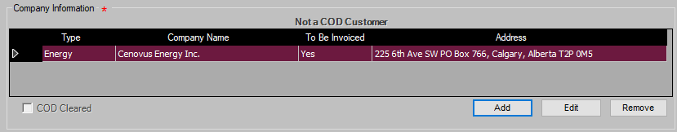

**Call Sheet Printout**

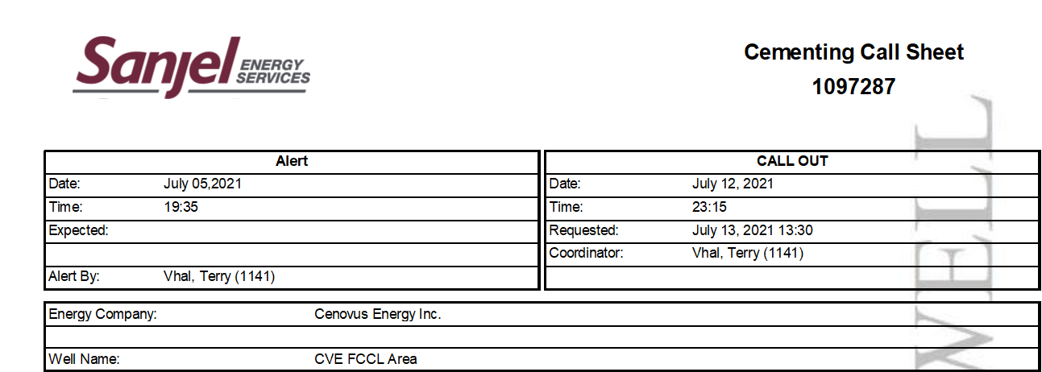

**Service Ticket Printout**

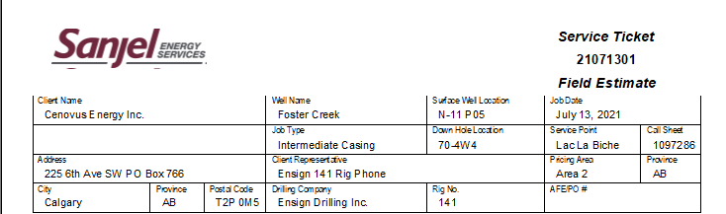

1. There is one Energy Company as the client, one consulting company is “To Be Invoiced”. This is most used company combination.

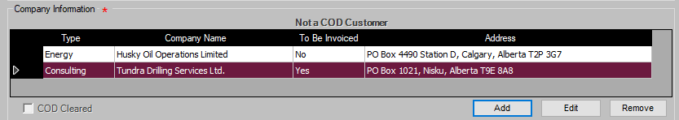

**Call Sheet Printout**

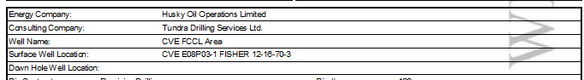

**Service Ticket Printout**

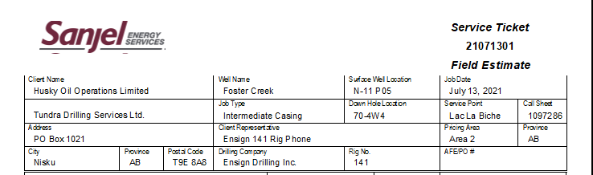

1. There is one Energy Company as the client and to be invoiced, one consulting company is not “To Be Invoiced”. This is Suncor/Syncrude case.

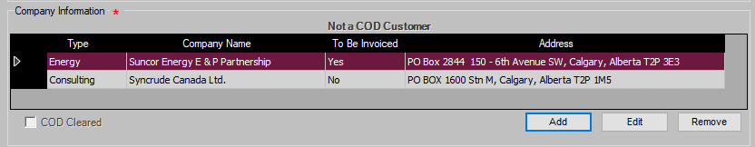

**Call Sheet Printout**

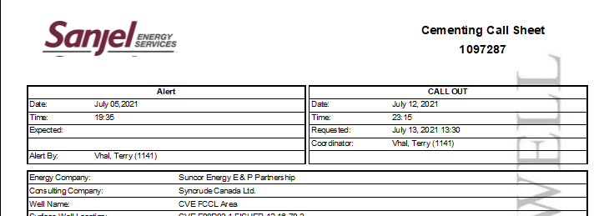

**Service Ticket Printout**

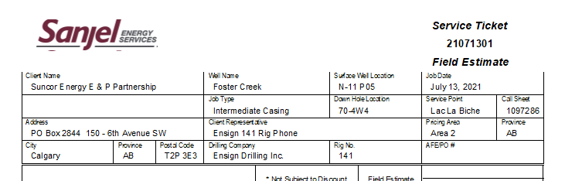

1. More companies involved in a job.

